DESTINATION EXP DESTINATION EXPERIENCE
●Cooking ●Reading ●Cycling ●Snorkeling ●Hiking ●Kayaking

PERSONAL INTERESTS / HOBBIES
TRAINING DEVELOPMENT/DELIVERY (10+ years)
●Customer Service Excellence ●Next-Level Leadership ●Professional/Executive Education ●University classes
EVENT PLANNING/FACILITATION (10+ years)
●Academic conferences and events ●Focus groups
BUSINESS/MANAGEMENT CONSULTING (20+ years)
Client/partner development ●Relationship management
RELEVANT PROFESSIONAL EXPERIENCE
INTERNATIONAL
Europe
Austria ●Czech Republic ● England ●France ●Hungary ●Ireland ●Italy ●Netherlands ●Northern Ireland ●Portugal ●Scotland (9 months) ●Spain ●Switzerland
Latin America / Caribbean
Argentina ●Belize ●Brazil ●Cayman Islands ●Chile ●Costa Rica ●Dominican Republic (2.5 years) ●Jamaica ●Puerto Rico
Middle East
United Arab Emirates
DOMESTIC
Charleston ●Grand Tetons ●Miami ●Myrtle Beach ●New Orleans ●North Carolina ●Orlando ●Savannah ●Washington, DC (Certified Washington, DC Guide) ●Yellowstone

DESTINATION EXPERIENCE

TAUCK 2022 – Present
WORLDSTRIDES 2022 – Present
EF TOURS – 2023 – Present
EDUCATIONAL TRAVEL ADVENTURES 2022 - 2023
PROFESSIONAL PROFILE

TOUR DIRECTOR EXPERIENCE
Bilingual Tour Director passionate about creating life-changing travel experiences for guests while ensuring positive impact for the local culture, economy, and environment.
TOUR DIRECTOR
CONTACT
pamela.j.santos@gmail.com
919.931.5563 Gateway City: Raleigh, NC
Gateway Airport: RDU
Citizenship: USA
Video Introduction

SKILLS
● Leadership ●
● Customer Service ●
● Program Management ●
● Cultural Awareness ●
● Training/Facilitating ●
● Research ●
● Event Planning ●

LANGUAGES
English ●●●●●
Spanish ●●●●●

EDUCATION
CERTIFIED TOUR DIRECTOR
CERTIFIED TOUR GUIDE
International Tour Management Institute
MASTER OF BUSINESS ADMINISTRATION (MBA)
University of North Carolina

BACHELOR OF SCIENCE
Management/Marketing
Economics Minor
University of North Carolina at Greensboro

PAMELA SANTOS
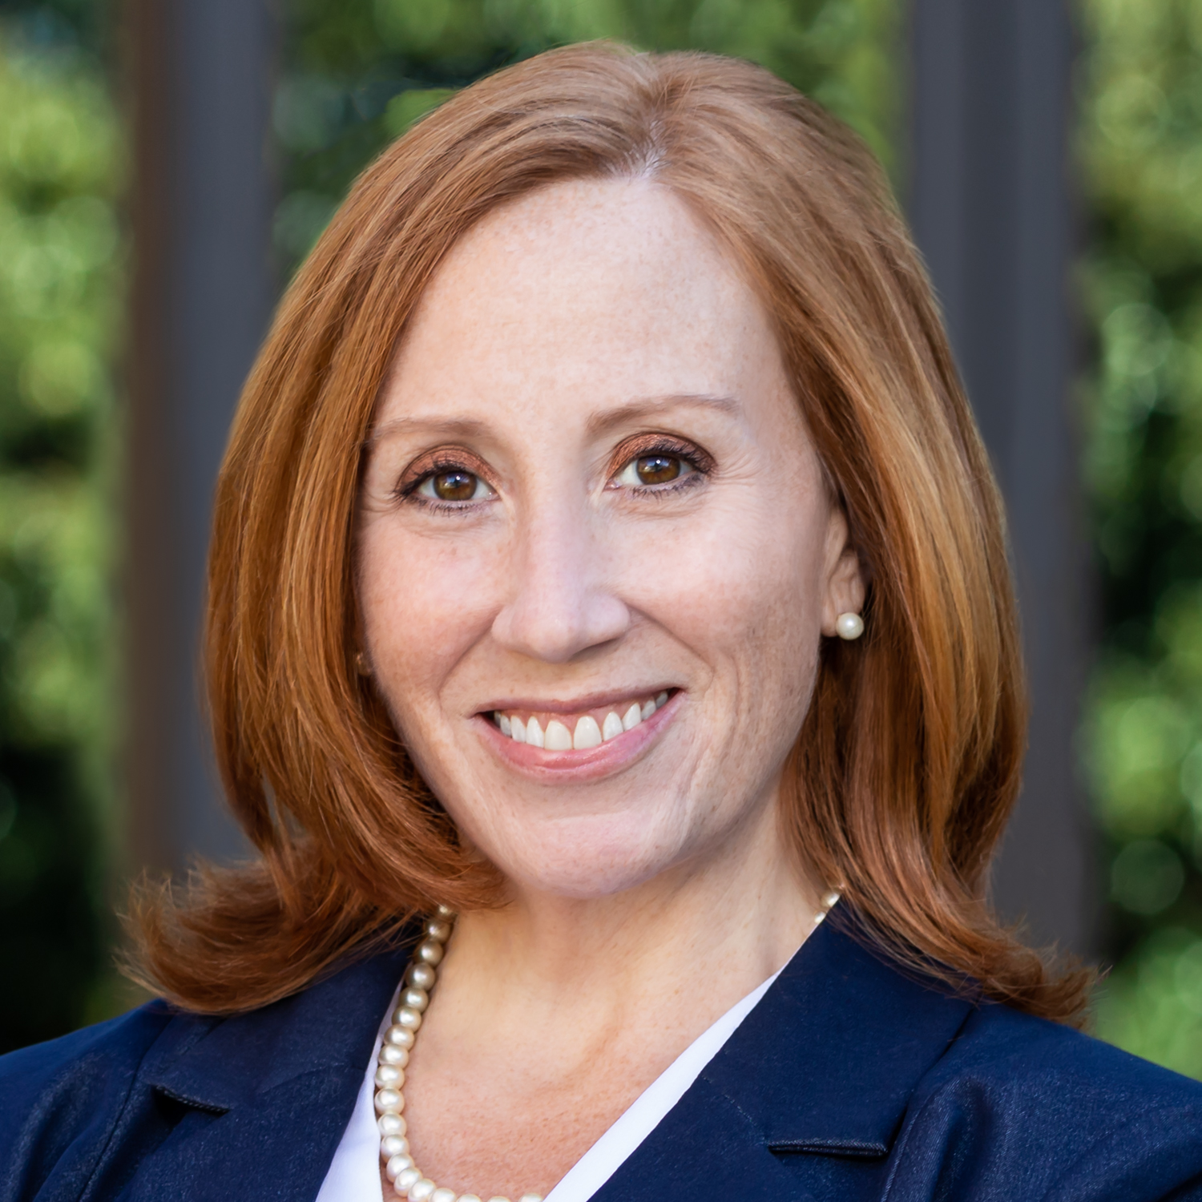
PS

PROGRAM DIRECTOR

CONTACT
pamela.j.santos@gmail.com linkedin.com/in/pamelajsantos
919.931.5563 Raleigh NC 27609
SKILLS
Leadership
Strategy
Social Entrepreneurship
Cross-Sector Partnerships
Program Design
Consulting
Training Programs
Strategic Business Planning
Cultural Elasticity
Research

EDUCATION
MASTER OF BUSINESS ADMINISTRATION (MBA)
University of North Carolina Kenan-Flagler Business School
BACHELOR OF SCIENCE University of North Carolina at Greensboro Business Management Economics Minor

