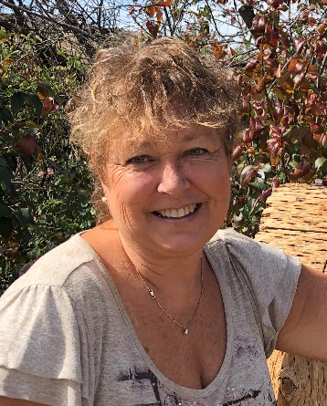

Certifications

Tour Director Experience

Languages

Additional Certifications

Additional Experience

Personal Interests

Susan Narte
snarte57@gmail.com
(509)393-9798
East Wenatchee, WA – SEA, EAT, BLI,
Facebook: Sightseeing with Susan

Tour Director Certificate – The TripSchool
Received tour director certification through The Trip School in San Diego, CA in January 2020. Fundamental of Tour Direction (Online), Tech Workshop.
Tour Guide Certificate – Kapiolani Community College
Received Hawaii state tour guide certification in 2014.

Cheryl’s NW Tours LLC, Burien, WA 2020-2021
Tour Director, tours throughout Washington state

Discover Hawaii Tours, Oahu, HI 2014-2015
As a driver/Guide, I led tours around Oahu to Waimea Falls, Dole Plantation, Pearl Harbor, and all local tourist sites.

Roberts Hawaii – Hoku Divison, Oahu, HI 2015-2017
Driver/Guide that led tours around the island of Oahu to all tourist sites and Pearl Harbor. Also, Kauai

English

American Red Cross
First Aid and CPR certified

Customer Service and Sales. School District Food Service and Bus Driver. Chaperoned on Student East Coast Trip.

Traveling and History, Learning New Cultures, Cooking, Wine Tasting, knitting and craft bazaars, Outdoor Enthusiast and Camping.

Destination Experience
I have led tours to the following destinations:

WEST COAST
Hawaii:
Oahu – Pearl Harbor, Circle Island Tour
Kauai- Circle Island Tour, Waimea Canyon
Washington-Mt. Rainier, Mt. St. Helens, Olympic National Forest, Leavenworth, Whidbey Island, Columbia River

Destination Training
The TripSchool
San Diego Boot Camp

Adept Destination Knowledge
Domestic
Alaska: Anchorage, Ketchikan, Dutch Harbor, Pribilof Islands.
Hawaii: Oahu, Kauai
California: San Diego, San Francisco
Washington: Seattle, Bellingham, Leavenworth, Lake Chelan (wineries)
Canada: Vancouver BC

Places Traveled:
Domestic:
Oregon, California, Arizona, Nevada, Idaho, Colorado, Utah, Montana, Wyoming, North Dakota, Oklahoma, Texas, Louisiana, Florida, Washington D.C., Delaware, Maryland, New Jersey, Pennsylvania, Virginia, West Virginia.
Abroad:
Mexico, Canada, Caribbean, Italy, Germany, Austria, Hungary, Bosnia, Egypt, Greece, Czech Republic, Croatia, The Mediterranean Islands, The Netherlands.

Cruises:
The Caribbean, The Mediterranean.

