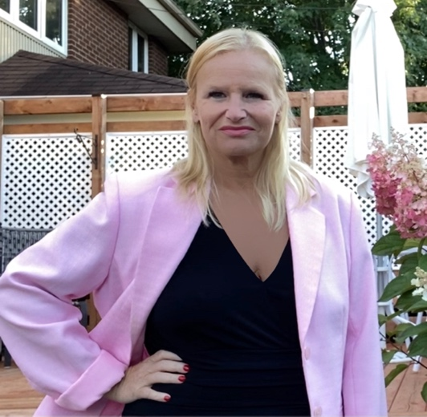
Patricia L’Heureux
(819) 352-5511 (c) • (819) 357-2639
(p.lheureux@hotmail.com
Gateway City: Montreal / Quebec
Citizenship: Canada
Video Introduction: https://youtu.be/jk7Ez9FqgxA

ITMI Certified Tour Director / Guide
Language: Fluent: French / English
Tour Director / Guide Experience
• Maritimes / United States (Fall 2019) (21 days senior Australians à la Carte Tour) with OExplora tours
• Canada / United States (summer 2018) (9 to 15 day tours) Destination America (Trafalgar) (52 x Australians/Americans/Europeens) + 1 tour (25 days) APT(AGT) (38 x Australians) + 1 tour (9 days) Newmarket Holidays (25 UK) + (winter 2017-2019) (several 4 to 7 day tours) Prométours (French immersion students) + 1 tour 2017 (9 days) Collette Vacations (45 x senior Americans)
• Southwest National Parks: (3 years) / Pacific Coast, Tour Operator Reservation agent / Tour Planning Agent
• San Francisco / Sausalito / Sonoma Wine Country Tour *ITMI FAM
• Monterey / Carmel / 17- Mile Drive / Steinbeck Center / Hearst Castle (2 days) *ITMI FAM
• Montreal / Quebec / Ottawa / Toronto / Niagara Falls (resident) *STRONG KNOWLEDGE
Strong Destination Knowledge / Cruise Experience / FAM Tours
• Eastern Canada / Maritime Provinces: Nova Scotia, New Brunswick, PEI,Toronto, Montreal, Ottawa, Niagara Falls, Kingston, Quebec (resident).
• Western Canada: / Canadian Rockies: British Columbia: Victoria, Vancouver, Whistler (resident 3 years), Alberta: Lake Louise, Banff, Jasper, Calgary.
• Washington D.C. / New York / Philadelphia / Boston / Chicago / Pennsylvania (Amish counties)
• Deep South / Florida: Memphis (resident 1 year), Miami, Ft. Lauderdale (travelles 15+x), Tampa (resident 1 month)
• Great Lakes: Chicago, St. Louis, Minneapolis, Buffalo, Detroit
• California / Nevada Napa, 17-Mile Drive (3x), Los Angeles (3x), Universal Studios (2x), Hollywood (3x), Beverly Hills (3x), Santa Monica (3x), Death Valley, Las Vegas (3x)
• Arizona / Utah / Wyoming Grand Canyon, Bryce, Zion, Arches, Monument Valley, Jackson Hole • Hawaii (3x) Oahu, Maui
• Mexico (travelled 12+x, 7-14 days) Cancun, Playa del Carmen, Riviera Maya, Cozumel
• Caribbean Cuba (travelled 12+x, 7-14 days), St. Thomas, Tortola, Puerto Rico
• Europe / British Isles France, England, London (resident 2 years), Cardiff (travelled 10+x),
• Eastern Mediterranean:
• Cruises: Royal Caribbean (Caribbean), Princess (Caribbean), Norwegian : (Maine & The Maritimes)
• Morocco : Casablanca, Agadir

Meeting and Event Planning
• Coordinated / Planned Events / Sales Meetings / Weddings (2 years, up to 600 people) Hotel • • •Organized Group Tour Itineraries (3 years) European guests, 50+ years old; TX, LA, FL, Chicago
Additional Experience and Skills
• Reservation Agent (3 years) Group Tour Operator
• Front Desk Agent (10 years) Hotels
• High School Teacher (15 years) English / French
• Workshop Leader / School Evaluator Worldwide, International Baccalaureate (IB) International
Program (15 years) Education
• Travel Agent (2 years) England

Education
• International Tour Management Institute, San Francisco – Certified Tour Director, July 2017 Laval
University, Quebec City, Canada – Bachelor’s Degree, Education
• April Fortier College – Tourism Certificate
• Red Cross / CPR Certified
TripSchool, several online classes: Story Telling, Bag of Tricks: Creative Ideas for Student Tours (Feb. 2021), Storytelling (August 2020) Create your Intro video (August 2020).

Personal Interests / Hobbies
•Travel, Swimming, learning Spanish, Cinema, Walking, Sudoku

