David G. Shaw  202-255-5685  david@offtherecordtours.com | 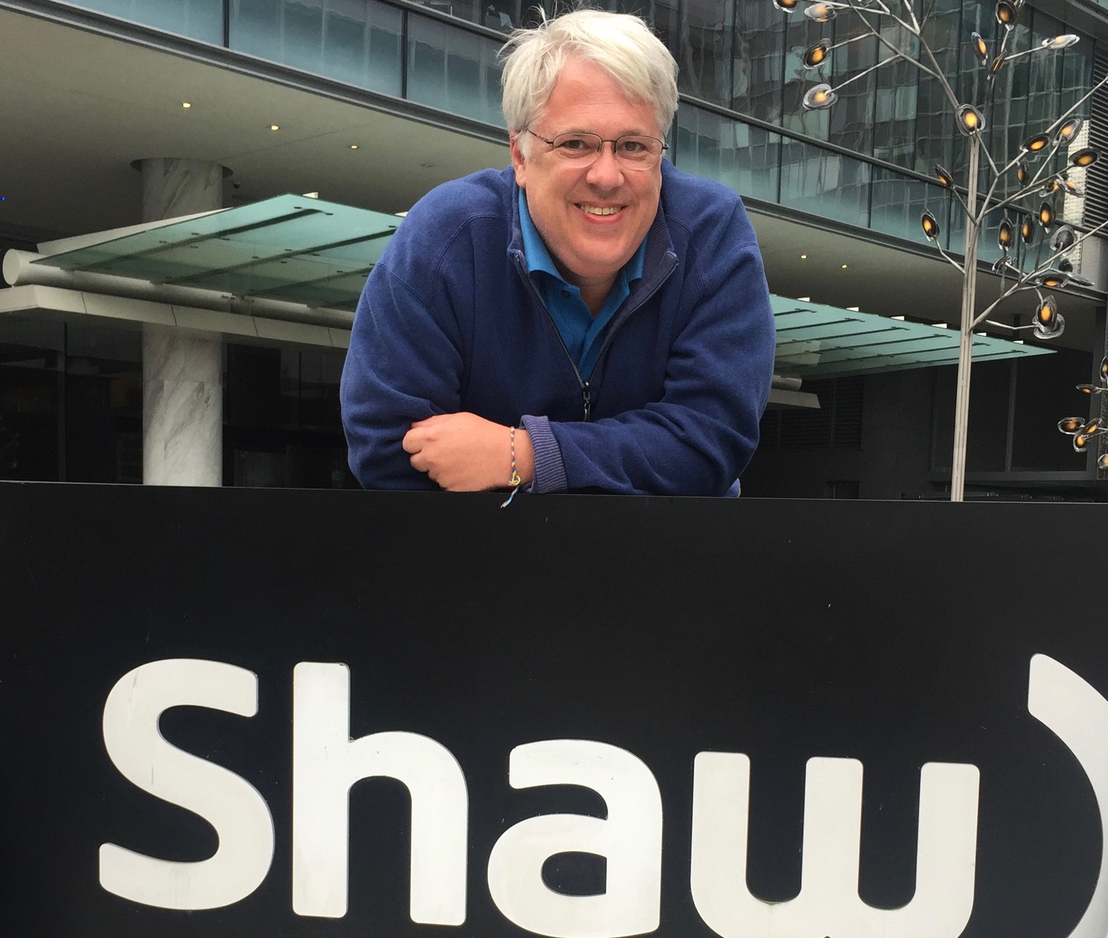

Off the Record Tours LLC, 2020 – present
I created this private tour company to tell the stories behind the sites in Washington. Specialized tours include Capitol Hill, Embassy Row, Arlington National Cemetery, and tours customized to the client’s needs. My motto: The crowd goes one way; we go the other.

International Visitor Liaison, U.S. Department of State, 2017 - present
I escort delegations of emerging foreign leaders that are official guests of the State Department on three-week multi-city tours where they experience the diversity of the United States. I manage hotel check-in, luggage transfer, sightseeing, facilitate professional meetings, and coordinate air and ground transportation. Duties require patience, tact, and diplomacy to maintain good working relationships with participants while representing the interests of the State Department. Clearance: Trusted

WorldStrides, 2011 - present
Conduct multi-day student tours in the Washington, DC area.

Additional Qualifications

US passport, TSA Pre/Global Entry, Microsoft Office, Filmora, first aid, CPR

Certifications

Tour Guide License, District of Columbia Department of Consumer and Regulatory Affairs
Certified Master Guide, Guild of Professional Tour Guides of Washington, DC
Sightseeing Guide License, New York City Department of Consumer Affairs
Certified Guide, Washington National Cathedral
Certified Guide, Association of Philadelphia Tour Guides

Employment

Accenture LLP, Government Marketing Manager, 1998 - 2001
Unisys Corporation, Business Development Manager, 1993-97
American Public Welfare Association, Project Manager, 1990-93

National Governors’ Association, Policy Analyst, 1988-90

Pennsylvania Department of Public Welfare, Program Analyst, 1987-88

Education

Bryn Mawr College, Master of Social Work & Master of Law and Social Policy

Elizabethtown College, Bachelor of Science

