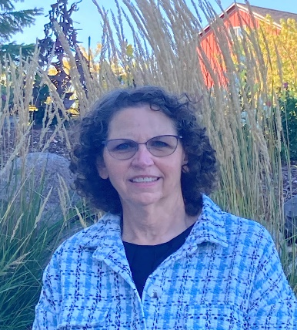
Diane L. Bonde, CITM
Sheboygan, WI
Phone: 920-980-9503
dianebondetravels@gmail.com

Introduction Video:
https://tinyurl.com/DianeBonde
Destination Experience:
Alaska

Gateway Cities:
Milwaukee and Green Bay

Experience:
Tourism and Hospitality: Tour Director for Princess Cruise Line, Alaska. Marketing presentations for Holland America On Stage Alaska program; Tour guide for Green Bay Packers stadium tours, WI; and Quinault Rainforest Tour, WA; Front desk agent checking in guests, explaining activities available and answering general questions.

Management: I have held management positions providing leadership, training employees, and communicating with vendors and customers for 20 years. I have a background in agriculture.

Customer Service: I have 12 years of customer service experience. Deliver communication in person and over the phone to internal and external customers.

Education:
Certified International Tour Manager, International Guide Academy, Denver, CO
Certified Tour Guide, International Guide Academy, Denver, CO
American Red Cross-Certification-Adult and Pediatric First Aid/CPR/AED
Master of Science in Management and Organizational Behavior, Silver Lake College, Manitowoc, WI

Skills & Interests:
Reading – Ebooks, audiobooks and traditional books…so many choices!
Walking – I have a goal to do a 10K walk in every state. Ask me about my most unique walk!
I enjoy meeting people and learning about an area. I am comfortable with small and large groups.
Member of Toastmasters International

