®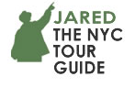

(917) 533-1057
Jared@JaredtheNYCTourGuide.com JaredtheNYCTourGuide.com

Jared Goldstein
OBJECTIVES
- Memorable historic, cultural, and architectural tours for over 50,000 including an alligator hunter, a governor, and a sheikh.
- Enthusiasm, passion, accuracy, fun.
• Outstanding service.
• Making my clients look great and keeping them for years.

QUALIFICATIONS
- Star-Level Licensed New York City Sight-Seeing Guide since 2005
#1212490-DCA, through March 31st 2022.
- Insured.
- American Heart Association First Aid, CPR, and AED Certification 2020-22.
- Certified by the Guides Association of NYC, GANYC since 2018.

EXPERIENCE
• Walking tours, Step-on coach bus Guide, and Tour Manager.
- Tour product developer, writer, and trainer.
• SUV, Walking, Subway, or Boat tours for: Tour Operators, Receptive Travel Companies, schools, colleges, walking tour companies, independent travelers, and Concierges’ guests.
• Custom tours for adult and student groups, and independent travelers.

LEADERSHIP and RECOGNITION
• TripAdvisor 2020 Travelers’ Choice Award. Certificates of Excellence 2016, 2017 and 2019 for hundreds of five-star reviews.
• ‘Tour Guide of the Year’ from Receptive Tour Operator Beyond Times Square in 2013.
• Chief NYC Guide, Equity UK Student Tours since 2010, Tour Guide since 2008.
• Chief NYC Guide for American Cruise Lines since 2009, Tour Guide since 2008.
- Editor of the Guides Association of NYC’s magazine, Guidelines, 2007-2008.
• Vice President, Guides Association of New York (GANYC) 2007-2009.
• Tour Developer, Leader and Trainer for “Heroes of the World Trade Center” for public walking-tour company. Since 2009, this is this company’s highest-rated and top product.
• Tour Developer, Leader and Trainer for the official tour of the South Street Seaport, “Sails to Sails,” from 2010 to 2012, until Hurricane Sandy.
• Featured in The New York Times for my “Santa the NYC Tour.”

LEARNING
• New York University: Manhattan 19th Century History.
- Cooper Union: The City Transformed, NYC history and architecture from the 17th Century to the present.
• Victorian Society in America’s 18th-20th century architecture, design, and social history course.
• Metropolitan Museum of Art’s Twentieth Century Architecture & Design Department’s Helena Rubenstein Foundation program.
• National Federation of Tour Guides Associations Conference 2016, 2018, 2020.
• International Association of Tour Directors and Guides Conference (ITATDG) 2016, 2017, and 2018.
• Columbia Graduate School of Business M.B.A. in Services Marketing. Student Service Award. President, Students for Responsible Business.
• Columbia College, Columbia University B.A. in English Literature. Awards for leadership, citizenship, arts, service and academics; Baccalaureate Address Speaker; Senior Class Award; Student Council President two years; Class President.

REFERENCES
Beyond Times Square, Receptive Tour Operator, Tour Guide since around 2006. Eric Gordon, Founder: EricJayGordon@Gmail.com (917) 209-7977.
2013’s “Tour Guide of the Year.” Tours for student and adult groups, and independent domestic and international travelers.

Executive Travel, Nebraska. Anne Fuldby-Olsen, Director of Groups, Meetings & Incentives. AnneF@ExecutiveTravel.com, (402) 858-0036. NYC Tour Guide for adults since 2014.
Travel Passport, Utah. Tour Guide for student arts groups since 2013. Carla Teasdale, Group Travel Expert, CarlaTravelP@yahoo.com, 801-423-1081.
Hudson River Valley Tours. NYC Tour Guide for adult groups since 2007.
Cathy Ellis: Info@HRVTours.com (845) 658-3101.

LEADING CLIENTS
Fuller list available upon request
New York City Department of Parks and Recreation. Developed and led “Community Gardens of the East Village” tour for National Gardening Month 2007.
Bud Light, 2014 Super Bowl Contest Winners NYC tour for domestic adult group.
Concierge’s guests’ tours (direct and through receptive tour operators) for these fine hotels: Andaz, Baccarat, The Benjamin, Equinox Hotel, Essex House, Four Seasons Midtown and Downtown, InterContinental, Langham, Lotte Palace, Mandarin Oriental, The Mark, Pierre, Plaza, St. Regis, Sherry-Netherland, Trump International, and Warwick.

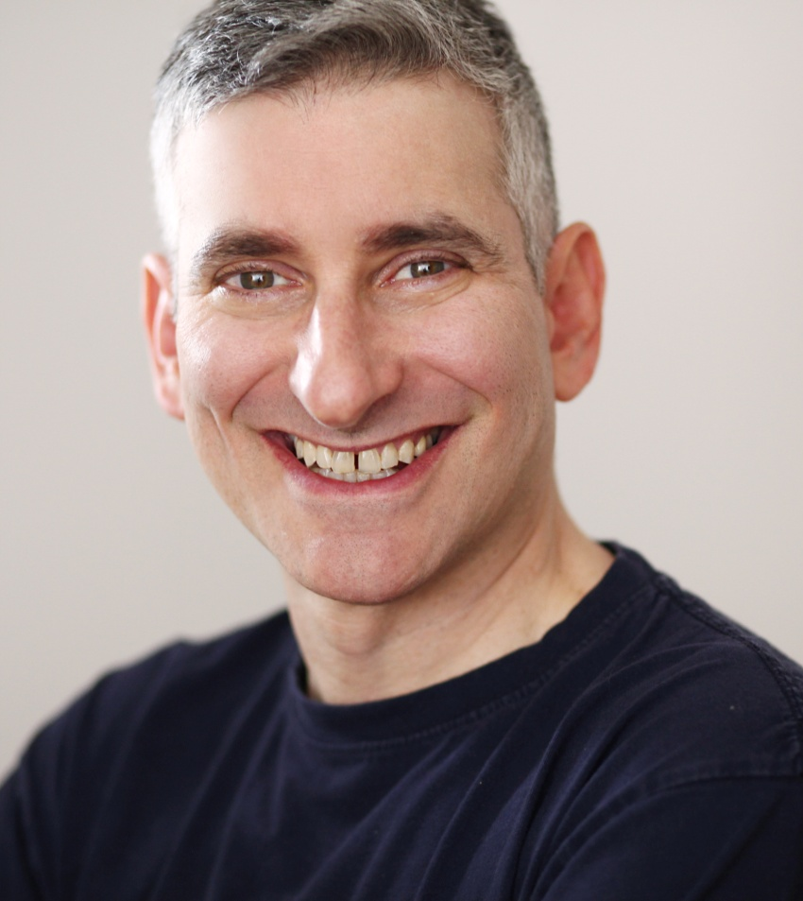
Jared Goldstein
(917) 533-1057
Jared@JaredtheNYCTourGuide.com
JaredtheNYCTourGuide.com

®

