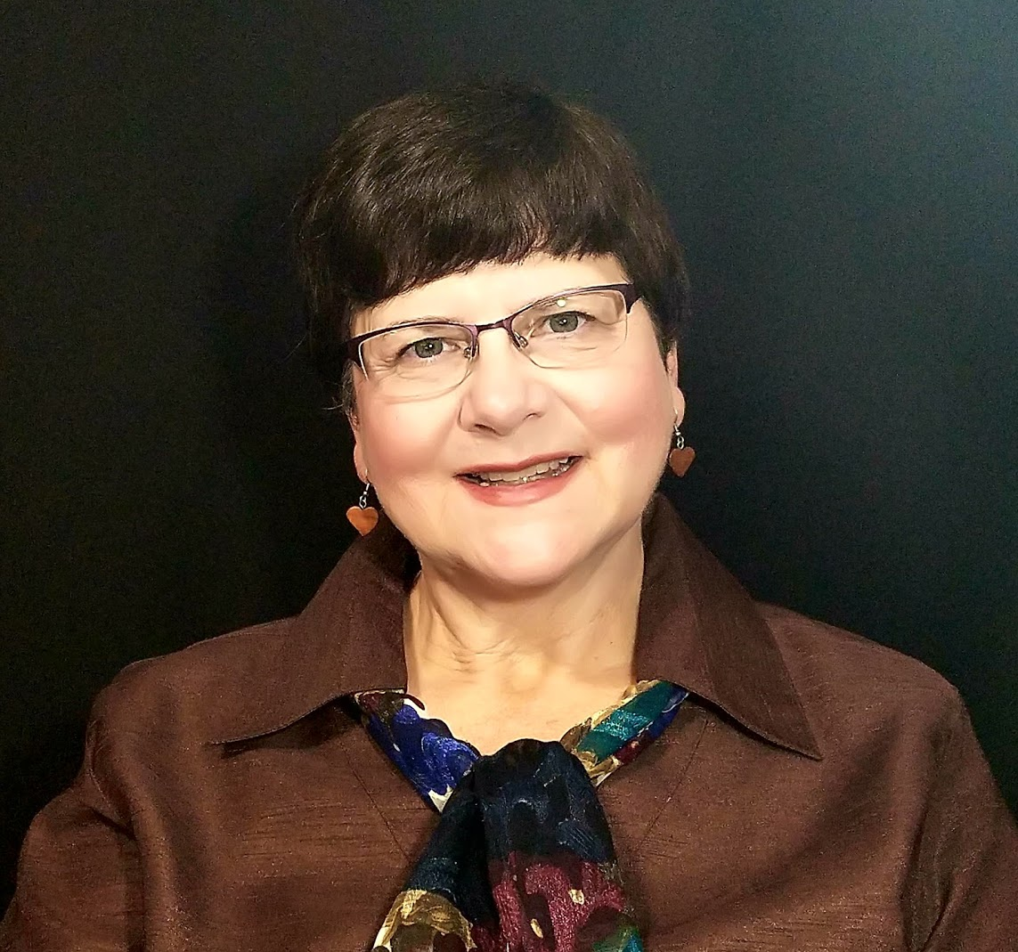
Terry A Rose
140 Alpine Circle • Brooksville, FL 34601
(352) 238-9072 • TerryARose20@gmail.com
Gateway City: Tampa/Orlando Citizenship: United States

ITMI Certified Tour Director
Washington DC Licensed/New York City Licensed

Career Objective: To facilitate an experience of joy, excitement and
discovery through travel- for all age groups-at home
and abroad.
Languages: Spanish: Semi-Fluent (Meet and Greet)
Student Tour Director/Guide Experience
- 7 years Washington D.C. Area City Tour
- 5 years “over the road” Christian Discoveries Tours
- 4 years New York City Tours
- 4 years The Historic Triangle of Virginia and Monticello
- 4 years Philadelphia and Pennsylvania Dutch Country
- 4 years Tampa and Orlando City Tours and Theme Parks
- 3 years West Central Florida Environmental Science Tours
- Florida Colleges and Career Tour Escort
- Washington DC and Virginia College Tour Escort

Adult Tour Director/Escort Experience
- 2 years with National Parks West Yellowstone, Grand Teton, Mt. Rushmore for Globus
- 1 year with National Parks East Gettysburg, Great Smoky Mountains, Shenandoah for Cosmos
- 2 years with New England Fall Foliage for Vacations By Rail
- Northern Ireland Developed and led 4-day tour for 12 guests

Fam Trips and Trainings:
- Sugar Tours New England Tour Training
- Trip School Boston
- Trip School New York City
- IATDG Cruise Tour Training to Haiti and Jamaica
- Transforming Student Travel Training
- Dallas/Fort Worth/Austin 2 day Fam Tour
- Southern California/Palm Springs/Los Angeles ITMI Fam Tour
- San Francisco/Sausalito/Napa/Sonoma Wine Country, Lassen National Park 2 days ITMI Fam Tour
- Nashville 2 days ITMI Fam Tour

Additional Experience and Skills
- Spanish teacher for Pre-K thru 8th grade Methodist School Center, Brooksville, Florida
- Administrator for Missionary School 2 years Honduras, Central America
- Middle School Guidance Counselor
Eleven years Counseling, Scheduling and Sponsoring Builders Club service group (Kiwanis)
- Middle and High School Teacher 15 years Taught Science and Sponsored Nature Lovers Club

Education
- International Tour Management Institute, San Francisco - Certified Tour Director
- University of South Florida – MA Guidance and Counseling
- University of Florida – BS Health Education
- ESOL Certified
- CPR/First Aid/AED Red Cross Certified
Personal Interests: Exploring the world and creating moments of peace and joy for ALL through missions and community service.

